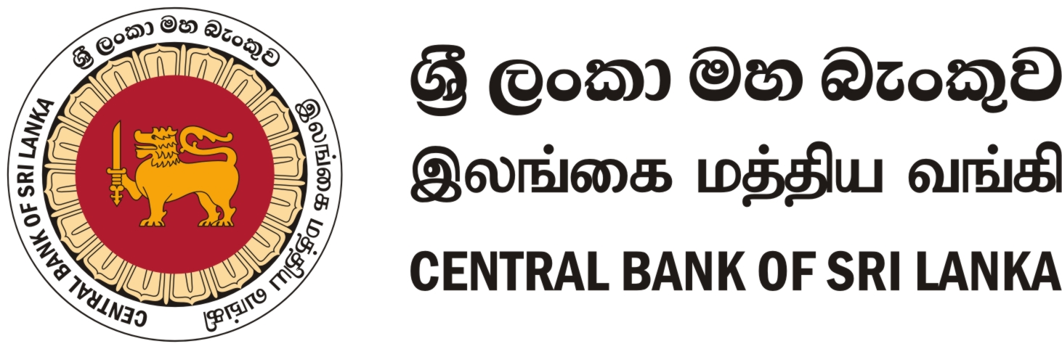

Communications Department
30, Janadhipathi Mawatha, Colombo 01, Sri Lanka.
Tel : 2477424, 2477423, 2477311
Fax: 2346257, 2477739
E-mail: dcommunications@cbsl.lk, communications@cbsl.lk
Web: www.cbsl.gov.lk

Press Release
Currency Department
09 November 2011

Central Bank of Sri Lanka wins 2011 Best New Banknote Series Finalist Award

The Central Bank of Sri Lanka (CBSL) had the honour of being selected as a finalist from among 17 nominations for the Best New Banknote Series award at the International Association of Currency Affairs (IACA) Conference held in Singapore from 2-5th October 2011. The new currency note series "Development, Prosperity and Sri Lanka Dancers" was issued by the CBSL in February 2011.

The Award was won by Bank of Uganda, while the Central Bank of Sri Lanka and the Central Bank of the Philippines won 2011 Best New Banknote Series Finalist awards. The award was received by De La Rue(DLR) the currency note printer of the new note series on behalf of the CBSL.

Mr. Tim Cobbold the CEO of DLR handed over the Finalist award to Mr. Ajith Nivard Cabraal the Governor, on 01 November 2011 at the Governor's office in the presence of Ms. Maria Atkinson, of De La Rue Currency, Mr. David Donalson Director and General Manager of De La Rue Lanka Currency and Security Print (Private) Ltd. Biyagama, Mrs. J. P. Mampitiya Assistant Governor and Mr. C.P.A. Karunatilake the Superintendent of Currency.

IACA is an organisation that provides an international forum for exchanges between central banks, financial institutions, suppliers and others who are stakeholders in the currency industry. The IACA awards are made every 18 months at the IACA Currency Conference and the Awards recognise and promote excellence in the currency industry. These awards are made for:

- Best New Banknote or Banknote Series,
- Best New Coin or Coin Series
- Best New Currency Feature
- Best New Currency Innovation, Process or Product
- Best Public Education Programme
- Best Currency Website
- Outstanding Achievement or Lifetime Achievement Award

